*Assignment 2 - Part 2 Submission*

*Adam Di Cioccio and Joshua Dixon*

*Lab Section 321*

*Souhail Abdala*

***Updated ERD Screenshot from Part 1 (Corrected version)***

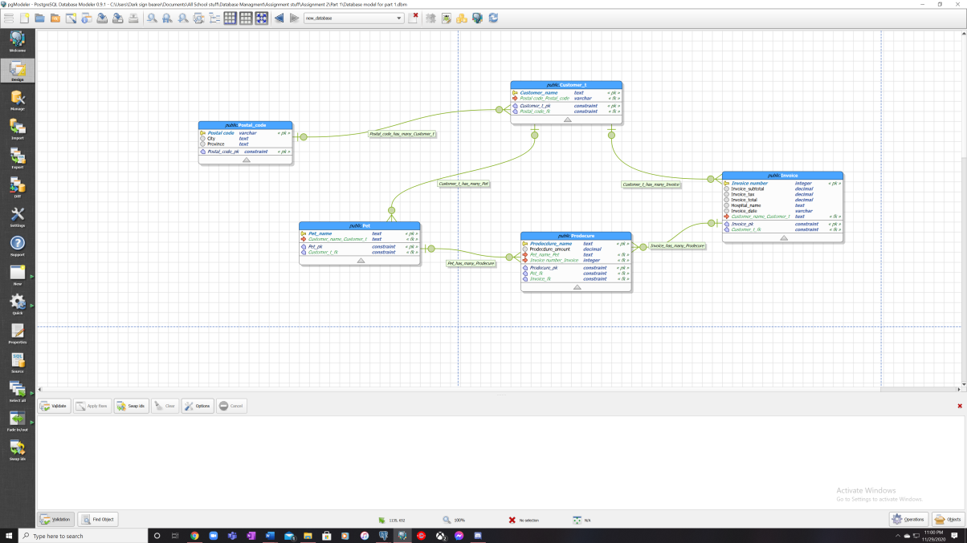

***Screenshots of tables***